ST. XAVIER’S COLLEGE

**Maitighar, Kathmandu**

**(Affiliated to Tribhuvan University)**



**Computer Graphics**

**Lab Assignment #8**

**REFELCT AN IMAGE ON X-AXIS AND Y-AXIS IN C++ BUILDER**

**Submitted By**

Prashraya Hada

013BSCIT027

**Submitted To**

Er. Anil Shah

Lecturer

Department of Computer Science

St. Xavier’s College

Maitighar, Kathmandu

**Submitted On**

8th September, 2015

**Algorithm:**

1. Get the width and height of the source image
2. Get parameter for reflection axis (1 for x-axis, 2 for y-axis)
3. For each point i in width

For each point j in height

If parameter==1

The translated point (x’, y’) is given by

x' = i

y’ = - j

If parameter==2

The translated point (x’, y’) is given by

x' = - i

y’ = j

Plot the points (x’, y’) with the same color as source in destination

1. Stop

**Source code:**

//---------------------------------------------------------------------------

#include <vcl\vcl.h>

#pragma hdrstop

#include "reflection.h"

//---------------------------------------------------------------------------

#pragma resource "*.dfm"

TForm1 *Form1;

int i,j,a,b,x,y; //common for reflcetion

//---------------------------------------------------------------------------

__fastcall TForm1::TForm1(TComponent* Owner)

: TForm(Owner)

{

}

//---------------------------------------------------------------------------

void __fastcall TForm1::Button1Click(TObject *Sender)

{

x=Image1->Height;

y=Image1->Width;

for (i=0;i<=x;i++)

{

for (j=0;j<=y;j++)

{

a = i;

b = -j;

b = b+y;

Image2->Canvas->Pixels[a][b]=Image1->Canvas->Pixels[i][j];

}

}

}

//---------------------------------------------------------------------------

void __fastcall TForm1::Button2Click(TObject *Sender)

{

x=Image1->Height;

y=Image1->Width;

for (i=0;i<=x;i++)

{

for (j=0;j<=y;j++)

{

a = -i;

b = j;

a = a+x;

Image2->Canvas->Pixels[a][b]=Image1->Canvas->Pixels[i][j];

}

}

}

//---------------------------------------------------------------------------

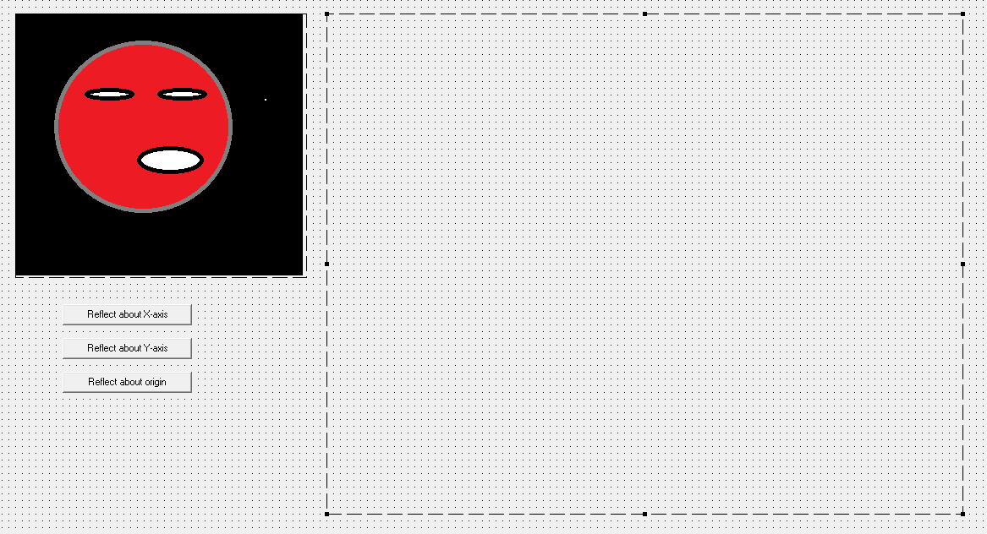

**Output:**

About X- axis

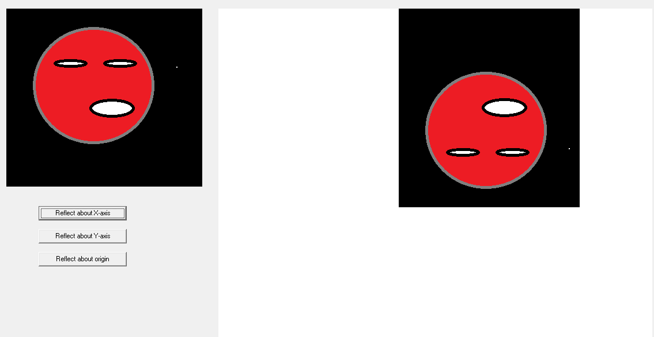

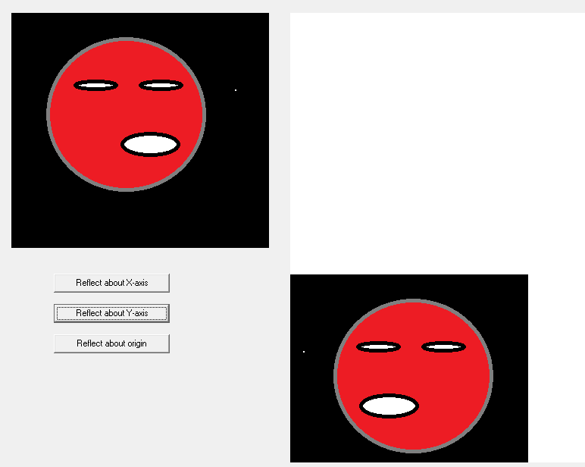About Y- axis